Operating system services
In this article, we understand the basics of an operating system and its services.

What do you mean by Operating system?
No matter its size and application, every computer needs an operating system to make it functional and useful. The operating system is an integral part of modern computer systems. It is a well-organized collection of programs that manages the hardware.
An Operating System provides an interaction between the users and computer hardware. A user is a person sitting at the computer terminal concerned about the application rather than the architecture of the computer. The user never interacts with the hardware directly. To get the services of the hardware, he has to request through the operating system.
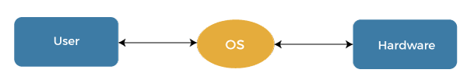
The operating system is a primary resource manager. It manages the hardware, including processors, memory, Input-Output devices, and communication devices.
Backward Skip 10sPlay VideoForward Skip 10s
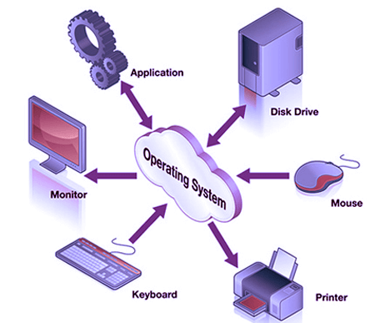
The operating system operates either in kernel mode or user mode. Compilers and editors run in user mode, whereas operating system code runs in kernel mode.
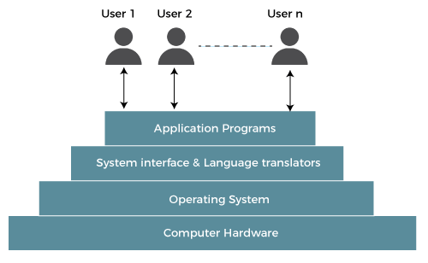

Operating system services:
The operating system provides the programming environment in which a programmer works on a computer system. The user program requests various resources through the operating system. The operating system gives several services to utility programmers and users. Applications access these services through application programming interfaces or system calls. By invoking those interfaces, the application can request a service from the operating system, pass parameters, and acquire the operation outcomes.
Following are the services provided by an operating system -
- Program execution
- Control Input/output devices
- Program creation
- Error Detection and Response
- Accounting
- Security and Protection
- File Management
- Communication
Program execution
To execute a program, several tasks need to be performed. Both the instructions and data must be loaded into the main memory. In addition, input-output devices and files should be initialized, and other resources must be prepared. The Operating structures handle these kinds of tasks. The user now no longer should fear the reminiscence allocation or multitasking or anything.
Control Input/output devices
As there are numerous types of I/O devices within the computer system, and each I/O device calls for its own precise set of instructions for the operation. The Operating System hides that info with the aid of presenting a uniform interface. Thus, it is convenient for programmers to access such devices easily.
Program Creation
The Operating system offers the structures and tools, including editors and debuggers, to help the programmer create, modify, and debugging programs.
Error Detection and Response
An Error in a device may also cause malfunctioning of the entire device. These include hardware and software errors such as device failure, memory error, division by zero, attempts to access forbidden memory locations, etc. To avoid error, the operating system monitors the system for detecting errors and takes suitable action with at least impact on running applications.
While working with computers, errors may occur quite often. Errors may occur in the:
- Input/ Output devices: For example, connection failure in the network, lack of paper in the printer, etc.
- User program: For example: attempt to access illegal memory locations, divide by zero, use too much CPU time, etc.
- Memory hardware: For example, Memory error, the memory becomes full, etc.
To handle these errors and other types of possible errors, the operating system takes appropriate action and generates messages to ensure correct and consistent computing.
Accounting
An Operating device collects utilization records for numerous assets and tracks the overall performance parameters and responsive time to enhance overall performance. These personal records are beneficial for additional upgrades and tuning the device to enhance overall performance.
Security and Protection
Operating device affords safety to the statistics and packages of a person and protects any interference from unauthorized users. The safety feature counters threats, which are published via way of individuals out of doors the manage of the running device.
For Example:
When a user downloads something from the internet, that program may contain malicious code that may harm the already existing programs. The operating system ensures that proper checks are applied while downloading such programs.
If one computer system is shared amongst a couple of users, then the various processes must be protected from another intrusion. For this, the operating system provides various mechanisms that allow only those processes to use resources that have gained proper authorization from the operating system. The mechanism may include providing unique users ids and passwords to each user.
File management
Computers keep data and information on secondary storage devices like magnetic tape, magnetic disk, optical disk, etc. Each storage media has its capabilities like speed, capacity, data transfer rate, and data access methods.
For file management, the operating system must know the types of different files and the characteristics of different storage devices. It has to offer the proportion and safety mechanism of documents additionally.
Communication
The operating system manages the exchange of data and programs among different computers connected over a network. This communication is accomplished using message passing and shared memory.

System Calls in Operating System (OS)
A system call is a way for a user program to interface with the operating system. The program requests several services, and the OS responds by invoking a series of system calls to satisfy the request. A system call can be written in assembly language or a high-level language like C or Pascal. System calls are predefined functions that the operating system may directly invoke if a high-level language is used.
In this article, you will learn about the system calls in the operating system and discuss their types and many other things.

What is a System Call?
A system call is a method for a computer program to request a service from the kernel of the operating system on which it is running. A system call is a method of interacting with the operating system via programs. A system call is a request from computer software to an operating system's kernel.
The Application Program Interface (API) connects the operating system's functions to user programs. It acts as a link between the operating system and a process, allowing user-level programs to request operating system services. The kernel system can only be accessed using system calls. System calls are required for any programs that use resources.
Backward Skip 10sPlay VideoForward Skip 10s

How are system calls made?
When a computer software needs to access the operating system's kernel, it makes a system call. The system call uses an API to expose the operating system's services to user programs. It is the only method to access the kernel system. All programs or processes that require resources for execution must use system calls, as they serve as an interface between the operating system and user programs.
Below are some examples of how a system call varies from a user function.
- A system call function may create and use kernel processes to execute the asynchronous processing.
- A system call has greater authority than a standard subroutine. A system call with kernel-mode privilege executes in the kernel protection domain.
- System calls are not permitted to use shared libraries or any symbols that are not present in the kernel protection domain.
- The code and data for system calls are stored in global kernel memory.

Why do you need system calls in Operating System?
There are various situations where you must require system calls in the operating system. Following of the situations are as follows:
- It is must require when a file system wants to create or delete a file.
- Network connections require the system calls to sending and receiving data packets.
- If you want to read or write a file, you need to system calls.
- If you want to access hardware devices, including a printer, scanner, you need a system call.
- System calls are used to create and manage new processes.

How System Calls Work
The Applications run in an area of memory known as user space. A system call connects to the operating system's kernel, which executes in kernel space. When an application creates a system call, it must first obtain permission from the kernel. It achieves this using an interrupt request, which pauses the current process and transfers control to the kernel.
If the request is permitted, the kernel performs the requested action, like creating or deleting a file. As input, the application receives the kernel's output. The application resumes the procedure after the input is received. When the operation is finished, the kernel returns the results to the application and then moves data from kernel space to user space in memory.
A simple system call may take few nanoseconds to provide the result, like retrieving the system date and time. A more complicated system call, such as connecting to a network device, may take a few seconds. Most operating systems launch a distinct kernel thread for each system call to avoid bottlenecks. Modern operating systems are multi-threaded, which means they can handle various system calls at the same time.

Types of System Calls
There are commonly five types of system calls. These are as follows:
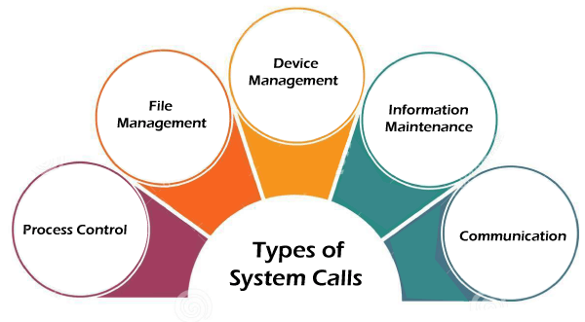
- Process Control
- File Management
- Device Management
- Information Maintenance
- Communication
Now, you will learn about all the different types of system calls one-by-one.

Process Control
Process control is the system call that is used to direct the processes. Some process control examples include creating, load, abort, end, execute, process, terminate the process, etc.

File Management
File management is a system call that is used to handle the files. Some file management examples include creating files, delete files, open, close, read, write, etc.

Device Management
Device management is a system call that is used to deal with devices. Some examples of device management include read, device, write, get device attributes, release device, etc.

Information Maintenance
Information maintenance is a system call that is used to maintain information. There are some examples of information maintenance, including getting system data, set time or date, get time or date, set system data, etc.

Communication
Communication is a system call that is used for communication. There are some examples of communication, including create, delete communication connections, send, receive messages, etc.

Examples of Windows and Unix system calls
There are various examples of Windows and Unix system calls. These are as listed below in the table:
Process | Windows | Unix
Process Control | CreateProcess()  ExitProcess()  WaitForSingleObject() | Fork()  Exit()  Wait()
File Manipulation | CreateFile()  ReadFile()  WriteFile()  CloseHandle() | Open()  Read()  Write()  Close()
Device Management | SetConsoleMode()  ReadConsole()  WriteConsole() | Ioctl()  Read()  Write()
Information Maintenance | GetCurrentProcessID()  SetTimer()  Sleep() | Getpid()  Alarm()  Sleep()
Communication | CreatePipe()  CreateFileMapping()  MapViewOfFile() | Pipe()  Shmget()  Mmap()
Protection | SetFileSecurity()  InitializeSecurityDescriptor()  SetSecurityDescriptorgroup() | Chmod()  Umask()  Chown()
Here, you will learn about some methods briefly:

open()
The open() system call allows you to access a file on a file system. It allocates resources to the file and provides a handle that the process may refer to. Many processes can open a file at once or by a single process only. It's all based on the file system and structure.

read()
It is used to obtain data from a file on the file system. It accepts three arguments in general:
- A file descriptor.
- A buffer to store read data.
- The number of bytes to read from the file.
The file descriptor of the file to be read could be used to identify it and open it using open() before reading.

wait()
In some systems, a process may have to wait for another process to complete its execution before proceeding. When a parent process makes a child process, the parent process execution is suspended until the child process is finished. The wait() system call is used to suspend the parent process. Once the child process has completed its execution, control is returned to the parent process.

write()
It is used to write data from a user buffer to a device like a file. This system call is one way for a program to generate data. It takes three arguments in general:
- A file descriptor.
- A pointer to the buffer in which data is saved.
- The number of bytes to be written from the buffer.

fork()
Processes generate clones of themselves using the fork() system call. It is one of the most common ways to create processes in operating systems. When a parent process spawns a child process, execution of the parent process is interrupted until the child process completes. Once the child process has completed its execution, control is returned to the parent process.

close()
It is used to end file system access. When this system call is invoked, it signifies that the program no longer requires the file, and the buffers are flushed, the file information is altered, and the file resources are de-allocated as a result.

exec()
When an executable file replaces an earlier executable file in an already executing process, this system function is invoked. As a new process is not built, the old process identification stays, but the new process replaces data, stack, data, head, etc.

exit()
The exit() is a system call that is used to end program execution. This call indicates that the thread execution is complete, which is especially useful in multi-threaded environments. The operating system reclaims resources spent by the process following the use of the exit() system function.

Components of Operating System
An operating system is a large and complex system that can only be created by partitioning into small parts. These pieces should be a well-defined part of the system, carefully defining inputs, outputs, and functions.
Although Windows, Mac, UNIX, Linux, and other OS do not have the same structure, most operating systems share similar OS system components, such as file, memory, process, I/O device management.
The components of an operating system play a key role to make a variety of computer system parts work together. There are the following components of an operating system, such as:
- Process Management
- File Management
- Network Management
- Main Memory Management
- Secondary Storage Management
- I/O Device Management
- Security Management
- Command Interpreter System
Operating system components help you get the correct computing by detecting CPU and memory hardware errors.
Backward Skip 10sPlay VideoForward Skip 10s
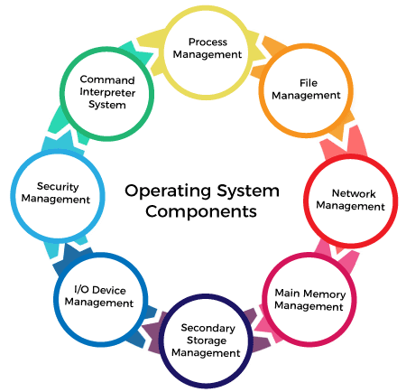

Process Management
The process management component is a procedure for managing many processes running simultaneously on the operating system. Every running software application program has one or more processes associated with them.
For example, when you use a search engine like Chrome, there is a process running for that browser program.
Process management keeps processes running efficiently. It also uses memory allocated to them and shutting them down when needed.
The execution of a process must be sequential so, at least one instruction should be executed on behalf of the process.
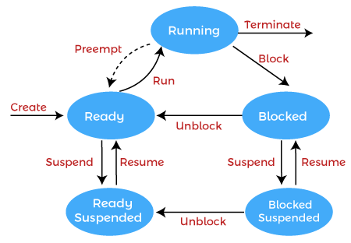
Functions of process management
Here are the following functions of process management in the operating system, such as:
- Process creation and deletion.
- Suspension and resumption.
- Synchronization process
- Communication process

NOTE: OS facilitates an exchange of information between processes executing on the same or different systems.

File Management
A file is a set of related information defined by its creator. It commonly represents programs (both source and object forms) and data. Data files can be alphabetic, numeric, or alphanumeric.
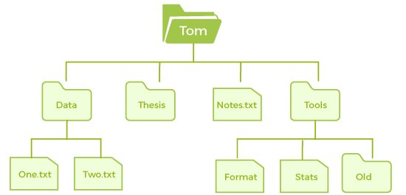
Function of file management
The operating system has the following important activities in connection with file management:
- File and directory creation and deletion.
- For manipulating files and directories.
- Mapping files onto secondary storage.
- Backup files on stable storage media.

Network Management
Network management is the process of administering and managing computer networks. It includes performance management, provisioning of networks, fault analysis, and maintaining the quality of service.
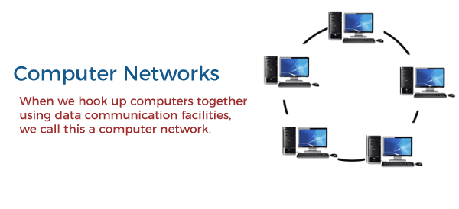
A distributed system is a collection of computers or processors that never share their memory and clock. In this type of system, all the processors have their local memory, and the processors communicate with each other using different communication cables, such as fibre optics or telephone lines.
The computers in the network are connected through a communication network, which can configure in many different ways. The network can fully or partially connect in network management, which helps users design routing and connection strategies that overcome connection and security issues.
Functions of Network management
Network management provides the following functions, such as:
- Distributed systems help you to various computing resources in size and function. They may involve minicomputers, microprocessors, and many general-purpose computer systems.
- A distributed system also offers the user access to the various resources the network shares.
- It helps to access shared resources that help computation to speed up or offers data availability and reliability.

Main Memory management
Main memory is a large array of storage or bytes, which has an address. The memory management process is conducted by using a sequence of reads or writes of specific memory addresses.
It should be mapped to absolute addresses and loaded inside the memory to execute a program. The selection of a memory management method depends on several factors.
However, it is mainly based on the hardware design of the system. Each algorithm requires corresponding hardware support. Main memory offers fast storage that can be accessed directly by the CPU. It is costly and hence has a lower storage capacity. However, for a program to be executed, it must be in the main memory.
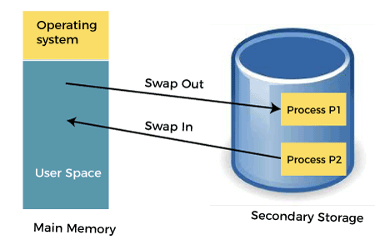
Functions of Memory management
An Operating System performs the following functions for Memory Management in the operating system:
- It helps you to keep track of primary memory.
- Determine what part of it are in use by whom, what part is not in use.
- In a multiprogramming system, the OS decides which process will get memory and how much.
- Allocates the memory when a process requests.
- It also de-allocates the memory when a process no longer requires or has been terminated.

Secondary-Storage Management
The most important task of a computer system is to execute programs. These programs help you to access the data from the main memory during execution. This memory of the computer is very small to store all data and programs permanently. The computer system offers secondary storage to back up the main memory.
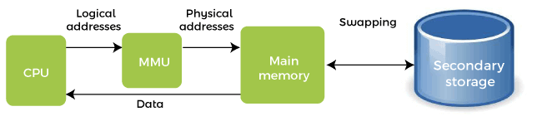
Today modern computers use hard drives/SSD as the primary storage of both programs and data. However, the secondary storage management also works with storage devices, such as USB flash drives and CD/DVD drives. Programs like assemblers and compilers are stored on the disk until it is loaded into memory, and then use the disk is used as a source and destination for processing.
Functions of Secondary storage management
Here are some major functions of secondary storage management in the operating system:
- Storage allocation
- Free space management
- Disk scheduling

I/O Device Management
One of the important use of an operating system that helps to hide the variations of specific hardware devices from the user.
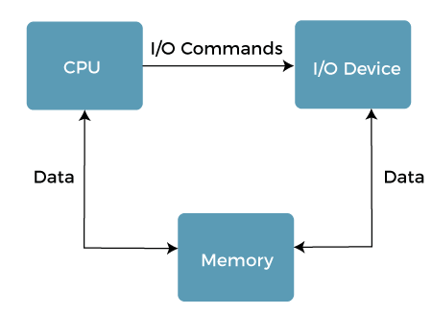
Functions of I/O management
The I/O management system offers the following functions, such as:
- It offers a buffer caching system
- It provides general device driver code
- It provides drivers for particular hardware devices.
- I/O helps you to know the individualities of a specific device.

NOTE: The user's program can't execute I/O operations directly. The operating system should provide some medium to perform this.

Security Management
The various processes in an operating system need to be secured from other activities. Therefore, various mechanisms can ensure those processes that want to operate files, memory CPU, and other hardware resources should have proper authorization from the operating system.
Security refers to a mechanism for controlling the access of programs, processes, or users to the resources defined by computer controls to be imposed, together with some means of enforcement.
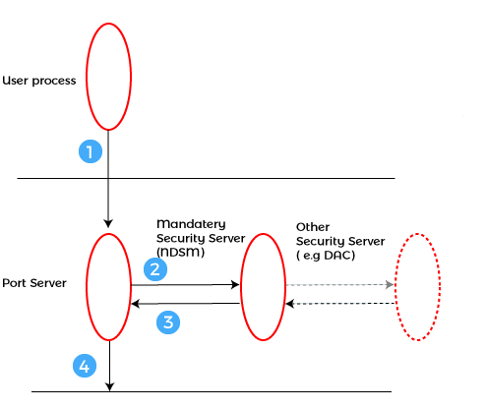
For example, memory addressing hardware helps to confirm that a process can be executed within its own address space. The time ensures that no process has control of the CPU without renouncing it. Lastly, no process is allowed to do its own I/O to protect, which helps you to keep the integrity of the various peripheral devices.
Security can improve reliability by detecting latent errors at the interfaces between component subsystems. Early detection of interface errors can prevent the foulness of a healthy subsystem by a malfunctioning subsystem. An unprotected resource cannot misuse by an unauthorized or incompetent user.

Command Interpreter System
One of the most important components of an operating system is its command interpreter. The command interpreter is the primary interface between the user and the rest of the system.
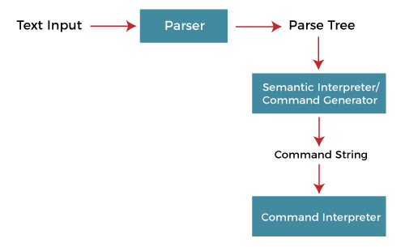
Many commands are given to the operating system by control statements. A program that reads and interprets control statements is automatically executed when a new job is started in a batch system or a user logs in to a time-shared system. This program is variously called.
- The control card interpreter,
- The command-line interpreter,
- The shell (in UNIX), and so on.
Its function is quite simple, get the next command statement, and execute it. The command statements deal with process management, I/O handling, secondary storage management, main memory management, file system access, protection, and networking.

Uses of Operating System
The operating system is used everywhere today, such as banks, schools, hospitals, companies, mobiles, etc. No device can operate without an operating system because it controls all the user's commands.
- LINUX/UNIX operating system is used in the bank because it is a very secure operating system.
- Symbian OS, Windows Mobile, iOS, and Android OS are used in mobile phone operating systems as these operating systems are a lightweight operating system.

Features of Operating System
The operating system has many notable features that are developing day by day. The growth of the operating system is commendable as it was developed in 1950 to handle storage tape. It acts as an interface. The features of operating system are given below.
- Error detection and handling
- Handling I/O operations
- Virtual Memory Multitasking
- Program Execution
- Allows disk access and file systems
- Memory management
- Protected and supervisor mode
- Security
- Resource allocation
- Easy to run
- Information and Resource Protection
- Manipulation of the file system

Characteristics of Operating System
Memory Management: The operating system manages memory. It has complete knowledge of primary memory; which part of the memory is used by which program. Whenever a program requests, it allocates memory.
Processor Management: It allocates the program to the processor (CPU) and also deallocates it when a program runs out of the CPU needs.
Device Management: The operating system keeps the information about all devices. It is also called the I/O controller, and the operating system also decides which devices are used to which program, when, and for how long.
Security: It prevents unauthorized access to any program. It uses passwords and other technologies.
Reliability: It is very reliable because no any virus and harmful code can be detected in it.
File Management: It allocates and deallocates resources and decides which program to allocate resources.
Easy to use: It can be easily used as it also has a GUI interface.

Needs of Operating System
The following points indicate the need for the operating system:
- More than one program runs at a time in a computer, and all of them require your computer's CPU and memory. The operating system manages resources for all those programs. That is why the operating system is required.
- Multitasking is a very critical feature of the OS. With its help, we can run many programs simultaneously.
- The operating system provides a platform to run any application program in the computer. Due to which we can do our work with the help of that application.
- It helps the user in file management. Through this, the user can save the data according to his needs.
- You use your mouse to open the application and click on the menu. All this is possible due to the modern operating system. This operating system allows you to do this with the help of GUI (Graphical user interface).
- The operating system creates a communication link between the user and the computer, allowing the user to run any application program and obtain the required output properly.
- It is almost impossible for a user to use a computer system without an operating system. Many processes run simultaneously when a program is executed, which is not easy for a person to manage.

Device Management in Operating System
Device management in an operating system means controlling the Input/Output devices like disk, microphone, keyboard, printer, magnetic tape, USB ports, camcorder, scanner, other accessories, and supporting units like supporting units control channels. A process may require various resources, including main memory, file access, and access to disk drives, and others. If resources are available, they could be allocated, and control returned to the CPU. Otherwise, the procedure would have to be postponed until adequate resources become available. The system has multiple devices, and in order to handle these physical or virtual devices, the operating system requires a separate program known as an ad device controller. It also determines whether the requested device is available.
The fundamentals of I/O devices may be divided into three categories:
- Boot Device
- Character Device
- Network Device

Boot Device
It stores data in fixed-size blocks, each with its unique address. For example- Disks.

Character Device
It transmits or accepts a stream of characters, none of which can be addressed individually. For instance, keyboards, printers, etc.

Network Device
It is used for transmitting the data packets.

Functions of the device management in the operating system
The operating system (OS) handles communication with the devices via their drivers. The OS component gives a uniform interface for accessing devices with various physical features. There are various functions of device management in the operating system. Some of them are as follows:
- It keeps track of data, status, location, uses, etc. The file system is a term used to define a group of facilities.
- It enforces the pre-determined policies and decides which process receives the device when and for how long.
- It improves the performance of specific devices.
- It monitors the status of every device, including printers, storage drivers, and other devices.
- It allocates and effectively deallocates the device. De-allocating differentiates the devices at two levels: first, when an I/O command is issued and temporarily freed. Second, when the job is completed, and the device is permanently release

Types of devices
There are three types of Operating system peripheral devices: dedicated, shared, and virtual. These are as follows:

1. Dedicated Device
In device management, some devices are allocated or assigned to only one task at a time until that job releases them. Devices such as plotters, printers, tape drivers, and other similar devices necessitate such an allocation mechanism because it will be inconvenient if multiple people share them simultaneously. The disadvantage of such devices is the inefficiency caused by allocating the device to a single user for the whole duration of task execution, even if the device is not used 100% of the time.

2. Shared Devices
These devices could be assigned to a variety of processes. By interleaving their requests, disk-DASD could be shared by multiple processes simultaneously. The Device Manager carefully controls the interleaving, and pre-determined policies must resolve all difficulties.

3. Virtual Devices
Virtual devices are a hybrid of the two devices, and they are dedicated devices that have been transformed into shared devices. For example, a printer can be transformed into a shareable device by using a spooling program that redirects all print requests to a disk. A print job is not sent directly to the printer; however, it is routed to the disk until it is fully prepared with all of the required sequences and formatting, at which point it is transmitted to the printers. The approach can transform a single printer into numerous virtual printers, improving performance and ease of use.

Features of Device Management
Here, you will learn the features of device management in the operating system. Various features of the device management are as follows:
- The OS interacts with the device controllers via the device drivers while allocating the device to the multiple processes executing on the system.
- Device drivers can also be thought of as system software programs that bridge processes and device controllers.
- The device management function's other key job is to implement the API.
- Device drivers are software programs that allow an operating system to control the operation of numerous devices effectively.
- The device controller used in device management operations mainly contains three registers: command, status, and data.

